

DATE TIME CHECKER

User Requirement

Project Code: FUHCM-SQA&T

Document Code: URD-FUHCM-SQA&T– v<0.1>

**<HCM, 16-6-2010>**

Record of change

*A - Added M - Modified D - Deleted

|  |  |  |  |  |
| --- | --- | --- | --- | --- |
| **Effective Date** | **Changed Items** | **A* M, D** | **Change Description** | **New Version** |
| 16-6-2010 | New document | A |  | 0.1 |
|  |  |  |  |  |
|  |  |  |  |  |
|  |  |  |  |  |
|  |  |  |  |  |
|  |  |  |  |  |
|  |  |  |  |  |
|  |  |  |  |  |
|  |  |  |  |  |
|  |  |  |  |  |
|  |  |  |  |  |
|  |  |  |  |  |
|  |  |  |  |  |
|  |  |  |  |  |
|  |  |  |  |  |
|  |  |  |  |  |
|  |  |  |  |  |
|  |  |  |  |  |
|  |  |  |  |  |
|  |  |  |  |  |
|  |  |  |  |  |

SIGNATURE PAGE

ORIGINATOR:

Name, Title Date

REVIEWERS:

Name, Title Date

Name, Title Date

APPROVAL:

Name, Title Date

TABLE OF CONTENTS

1 INTRODUCTION 5

1.1 Purpose 5

1.2 Scope 5

1.3 Definitions, acronyms and abbreviations 5

1.4 References 6

1.5 Overview 6

2 FUNCTIONALITY 7

2.1 User Interface 7

2.2 “Close” function 7

2.3 “Clear” function 8

2.4 Check Date Time function 8

3 REABILITY 12

4 PERFOMANCE 13

5 TECHNOLOGY RULES AND LIMITATIONS 14

5.1 Running Environment 14

5.2 Development Environment 14

5.3 Hardware 14

# INTRODUCTION

## Purpose

This URD describe the requirements of DateTimeChecker application. This document is used as a course material of Software Quality Assurance and Testing at FU-HCM.

## Scope

We need an application, DateTimeChecker, which can check whether the date time input is valid or not.

The release product must have characterizes:

* Program is written with C# language
* The program will be run all Windows platform with .NET framework 2.0 or upper.
* Release product includes: source code , installation software, test cases and test report.
* The user interface must be friendly and easy to use.
* Source code follow the C# coding convention.
* All functions must be tested.
* Duration of project is 14 days.

## Definitions, acronyms and abbreviations

|  |  |  |
| --- | --- | --- |
| **No** | **Acronym/Abbreviation** | **Description** |
| 1 | **UDD** | User Requirement Document |
| 2 | **DTC** | Date Time Checker application |
| 3 | **FU-HCM** | FPT University – HCM Campus |

## References

## Overview

In next sections, UDD will describe detail of each requirement of DTC. Requirements are divided in to sub-categories:

* Functionality
* Usability
* Reliability
* Performance

# FUNCTIONALITY

## User Interface

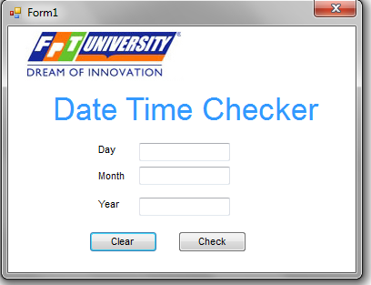

Figure 1: Screen Layout of DTC

Application must have the layout as figure 1:

* Picture box with FU Logo at the top-left corner.
* “Date Time Checker” text with fore color is “Blue” and Font Name is “Arial” and size is 26.
* “Day”, ”Month”, ”Year” texts must be left-align.
* Three textbox for inputting day, month, year
* Two button “Clear”, “Check”.
* Form without Maximize and Minimize box

## “Close” function

If user click “X” button, red button at the top-right, user will be asked by a Message Box:

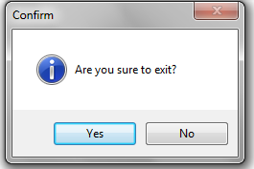

Figure 2: Confim Message Box

If user selects “Yes” option, application will exit.

If user selects “No” option, message box will close and application still exist.

## “Clear” function

If user click “Clear” button, text in 3 textboxes will be clear.

## Check Date Time function

* Algorithm for checking valid date time must be followed flowcharts below:

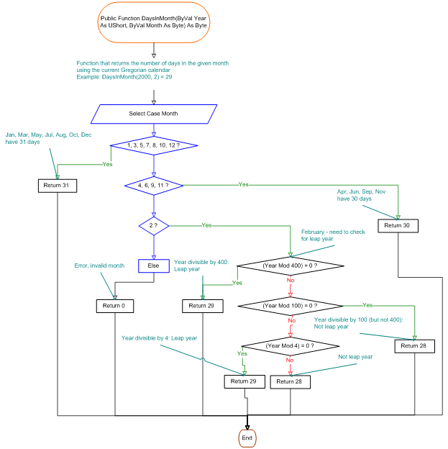

Figure 3: Check Day in Month

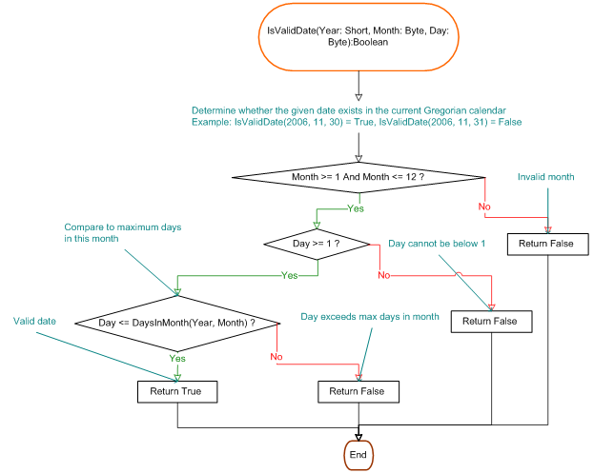

Figure 4: Check Date

* In “Day” textbox, user must be input integer number in rang 1-31.
* In “Month” textbox, user must be input integer number in rang 1-12.
* In “Year” textbox, user must be input integer number in rang 1000-3000.
* When user click button “Check”
  + If “Day” data input is not a number , Message Box will be shown:

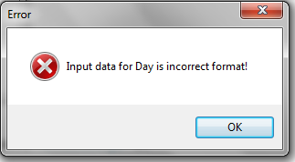

Figure 5: Error Message

* + If “Day” data input is a number but not in range, Message Box will be shown:

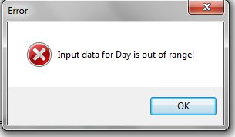

Figure 6: Error Message Out-of-Range

* Similar validation for “Month” and “Year” text box.
* If user input correct format of date time, DTC will check whether the data is valid or not:
  + If data is valid date time, Message Box will be shown (dd/mm/yyyy is replaced by actual value).

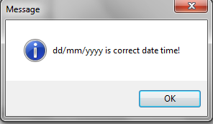

Figure 7: Correct Date Time Message Box

* + If data is invalid date time, Message Box will be shown (dd/mm/yyyy is replaced by actual value).

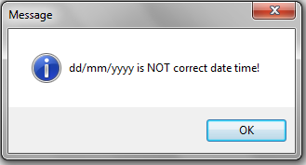

# REABILITY

* Application run smoothly without any crash failure.
* Checking result is compatible with Georgian calendar.

# PERFOMANCE

* Checking result must be appeared 1 second after clicking the “Check” button.

# TECHNOLOGY RULES AND LIMITATIONS

## Running Environment

* Application run on Windows XP SP2 or higher
* Application can run on .NET Framework 2.0 or higher.

## Development Environment

* DTC will be developed on VS2005 or VS2008

## Hardware

Machine for running DTC application:

* CPU: Pentim IV or higher
* RAM: 512 or higher